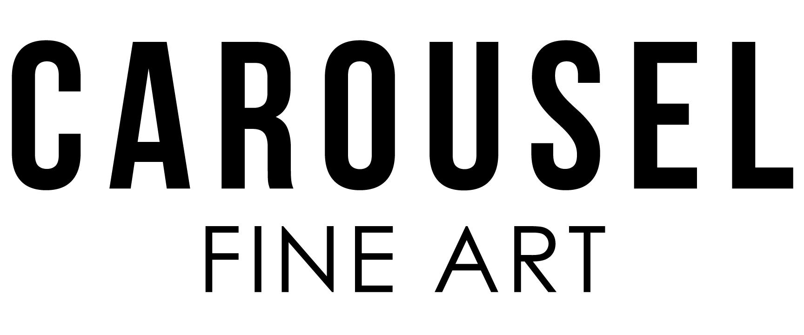

Carousel Fine Art

hello@carouselartgroup.com

+1 786.475.9124

Good morning,

Happy new year! I hope this email finds you well.

We write to you with an exciting event in the works. "**It's in the Cards**" by Cayla Birk Explores the Intricacies of Lotería and Modern-Day Fortune. We invite you to this evening at the gallery and to share this invite with your art connoisseurs and most exclusive clients.

Miami, Florida (January, 2024) — **Carousel Fine Art** invites art enthusiasts and cultural aficionados alike to immerse themselves in the captivating world of "It's in the Cards," a thought-provoking evening featuring her latest series, "**Take the Lot.**" This collection is a visual exploration of Mexican Lotería cards, a cultural phenomenon that traces its roots to the early history of playing cards, specifically the popular Tarot game that has transcended time and borders since the 15th century.

Birk's series delves into the rich history of Lotería, a Mexican bingo-like game that evolved from the traditional Tarot game, which, in turn, originated from Italian playing cards in the 15th century. Predominantly a gambling game, the Church sought to create a less heretic version, which led to the development of the "cards of divination." Eventually, this concept became known as the modern-day Tarot.

Cayla Birk's "Take the Lot" skillfully weaves together the familiar imagery of Lotería cards with a contemporary commentary on the acquisition of high-end assets. The juxtaposition of a game of chance against the financial means required to obtain such prized possessions is a recurring theme throughout the series. Birk challenges the notion of accepting fate and instead encourages viewers to forge their own destinies—to take the lot.

The event will take place January 18th at Carousel Fine Art, located in Ironside, Miami. This sensory journey promises to transcend borders and time, inviting visitors to reflect on the intersections of culture, history, and the pursuit of fortune. Partnering with **Santo Gusano Mezcal**, a local Miami Mexican Mezcal, will enhance the cultural experience of the Take The Lot series.

We'd be delighted if you'd consider sharing our invitation. Should you require further information please don't hesitate to reach out to us.

Event Details:

**Title:** It's in the Cards

**Artist:** Cayla Birk

**Series:** Take the Lot

**Date:** January 18th, 2024, 7-10 PM

**Location:** Carousel Fine Art Gallery, (Ironside Development),

7620 NE 4th Ct, Miami, FL 33138.

**RSVP: hello@carouselartgroup.com**

About Cayla Birk:

Cayla Birk is a Florida based artist known for her innovative and thought-provoking work that often explores the intersection of culture, history, and contemporary society. With a diverse portfolio, Birk's art has been featured in numerous exhibitions and has garnered acclaim for its depth and relevance. Learn more about Cayla Birk and her work at <https://www.caylabirk.com/>

For more information about the event contact:

The Carousel Fine Art Team

hello@carouselartgroup.com

+1 786.475.9124